MILESTONE 1
Food Waste Management System
ERD & Relational Database Schema

Subject | Database
Instructor | Ali Hassan
Group Members | Faraz Qazi, Maaz Ali
Semester | 4th Semester
Submission Date | April 26, 2025
Milestone | 1 — ERD & Relational Schema (V2)

SECTION 1
Project Overview

The Food Waste Management System connects restaurants with NGOs to reduce surplus food waste. Restaurants post available food listings and NGOs claim items for distribution to communities in need.
This document covers Milestone 1: the Entity-Relationship Diagram (ERD) and full Relational Database Schema for the system.
SECTION 2
Entity-Relationship Diagram

The diagram below shows all entities, attributes, primary/foreign keys, and relationships. Core tables are displayed in color; optional feature tables are shown in lighter tones.

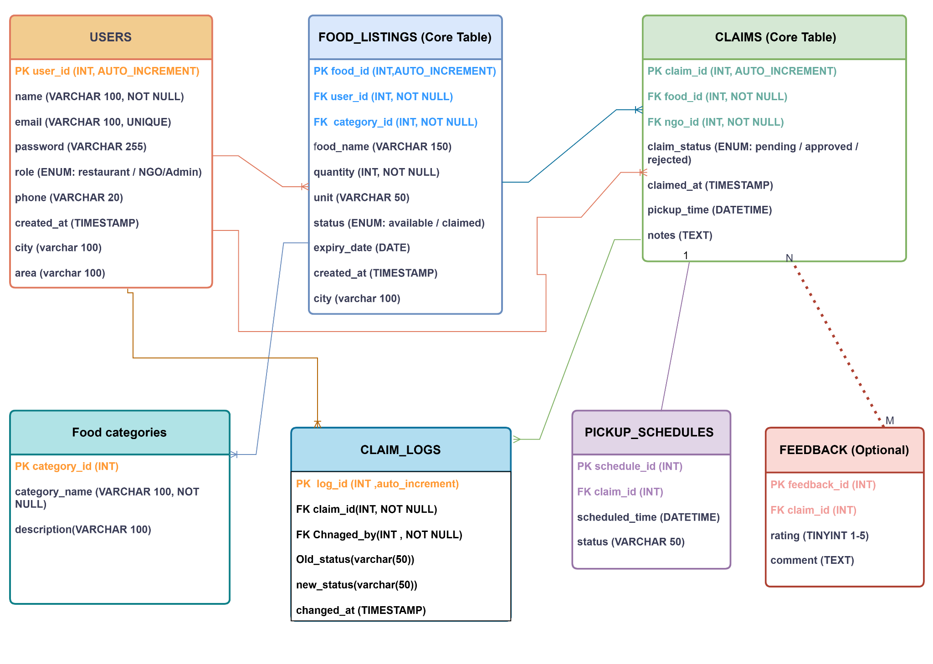
Figure 1 — Entity-Relationship Diagram, Food Waste Management System
SECTION 3
Relational Database Schema

The schema consists of three core tables, one mandatory table (pickup_schedules), one optional table (feedback), plus new tables for food categories, claim audit logs, and location fields — all using MySQL InnoDB for referential integrity support.
3.1 users
Central table storing all system users — restaurants, NGOs, and admins. The role field controls what each user can see and do. City and area fields enable location-based matching between restaurants and nearby NGOs.

Attribute | Data Type | Constraint | Description
user_id | INT | PK, AUTO_INCREMENT | Unique user identifier
name | VARCHAR(100) | NOT NULL | Full name of user
email | VARCHAR(100) | NOT NULL, UNIQUE | Login email address
password | VARCHAR(255) | NOT NULL | Hashed password
role | ENUM('restaurant','NGO','admin') | NOT NULL | Type of user account
phone | VARCHAR(20) | NULL | Contact phone number
created_at | TIMESTAMP | DEFAULT NOW() | Registration timestamp
city | VARCHAR(100) | NULL | City of the user/restaurant
area | VARCHAR(100) | NULL | Area/neighborhood of the user
3.2 food_listings
Stores all surplus food posted by restaurants. Each listing is tied to a restaurant (user_id), a food category (category_id), and a city for location filtering. Status switches from available to claimed once an NGO successfully claims the item.

Attribute | Data Type | Constraint | Description
food_id | INT | PK, AUTO_INCREMENT | Unique food listing ID
user_id | INT | FK → users(user_id) | Restaurant owner (FK)
food_name | VARCHAR(150) | NOT NULL | Name of food item
quantity | INT | NOT NULL | Amount available
unit | VARCHAR(50) | NULL | kg, portions, boxes…
status | ENUM('available','claimed') | DEFAULT 'available' | Listing availability
expiry_date | DATE | NULL | Best-before date
created_at | TIMESTAMP | DEFAULT NOW() | Listing creation time
category_id | INT | FK → food_categories(category_id), NULL | Food category (FK)
city | VARCHAR(100) | NULL | City where food is available
3.3 claims
Records every claim made by an NGO on a food listing. Links the food item and the NGO via foreign keys. The claim_status tracks the current stage of the claim — from pending through to completed or cancelled.

Attribute | Data Type | Constraint | Description
claim_id | INT | PK, AUTO_INCREMENT | Unique claim identifier
food_id | INT | FK → food_listings(food_id) | Claimed food item (FK)
ngo_id | INT | FK → users(user_id) | NGO user who claimed (FK)
claim_status | ENUM('pending','confirmed','completed','cancelled') | NOT NULL | Status of claim
claimed_at | TIMESTAMP | DEFAULT NOW() | Time claim was made
pickup_time | DATETIME | NULL | Scheduled pickup time
notes | TEXT | NULL | Additional notes
3.4 pickup_schedules
Stores the scheduled pickup time for each confirmed claim. This table is mandatory — every confirmed claim must have a corresponding pickup schedule. Ensures no confirmed claim is left without a planned collection time.

Attribute | Data Type | Constraint | Description
schedule_id | INT | PK, AUTO_INCREMENT | Unique schedule ID
claim_id | INT | FK → claims(claim_id) | Associated claim (FK)
scheduled_time | DATETIME | NOT NULL | Pickup datetime
status | VARCHAR(50) | DEFAULT 'pending' | Schedule status
3.5 feedback (Optional)
Allows NGOs to leave a rating and comment after a claim is completed. This is optional — NGOs are not forced to submit feedback. Ratings are constrained between 1 and 5 to maintain data quality.

Attribute | Data Type | Constraint | Description
feedback_id | INT | PK, AUTO_INCREMENT | Unique feedback ID
claim_id | INT | FK → claims(claim_id) | Associated claim (FK)
rating | TINYINT | CHECK (1–5) | Quality/service rating
comment | TEXT | NULL | Written feedback
submitted_at | TIMESTAMP | DEFAULT NOW() | Submission timestamp
3.6 food_categories
A simple lookup table that stores food types such as cooked, raw, bakery, and dairy. Separating categories into their own table avoids repeating category names across listings and keeps the schema in Third Normal Form (3NF).

Attribute | Data Type | Constraint | Description
category_id | INT | PK, AUTO_INCREMENT | Unique category ID
category_name | VARCHAR(100) | NOT NULL, UNIQUE | e.g. cooked, raw, bakery
description | TEXT | NULL | Optional category description
3.7 claim_logs
An audit trail that logs every status change made to a claim. Each row records the previous status, the new status, who made the change, and when. This allows admins to investigate disputes, track accountability, and analyze how long claims take to move through each stage.

Attribute | Data Type | Constraint | Description
log_id | INT | PK, AUTO_INCREMENT | Unique log entry ID
claim_id | INT | FK -> claims(claim_id) | Claim being tracked (FK)
changed_by | INT | FK -> users(user_id) | User who made the change (FK)
old_status | VARCHAR(50) | NULL | Previous claim status
new_status | VARCHAR(50) | NOT NULL | Updated claim status
changed_at | TIMESTAMP | DEFAULT NOW() | Timestamp of change
SECTION 4
Relationships & Cardinality

Relationship | Type | Description
users → food_listings | One-to-Many (1:N) | A restaurant posts many listings; each listing belongs to one restaurant.
users → claims (NGO) | One-to-Many (1:N) | An NGO places many claims; each claim is tied to one NGO.
food_listings → claims | One-to-Many (1:N) | A listing may receive claims; status updates to "claimed" on acceptance.
claims → pickup_schedules | One-to-One (opt.) | Every confirmed claim must have one pickup schedule (mandatory).
claims → feedback | One-to-One (opt.) | A completed claim may optionally receive NGO feedback.
food_categories -> food_listings | One-to-Many (1:N) | A category groups many listings; each listing has one category.
claims -> claim_logs | One-to-Many (1:N) | A claim has many log entries tracking its status changes.
users -> claim_logs | One-to-Many (1:N) | A user appears in many log entries as the one who changed status.
SECTION 5
Integrity Constraints

- Primary Keys — every table uses a surrogate INT AUTO_INCREMENT primary key.
- Foreign Keys — enforced via MySQL with ON DELETE RESTRICT to prevent orphaned records.
- UNIQUE — email in users is unique to prevent duplicate accounts.
- NOT NULL — critical fields (name, email, password, role) cannot be empty.
- ENUM — role, status, and claim_status are restricted to predefined valid values.
- CHECK — rating in feedback is constrained to values between 1 and 5.
SECTION 6
Normalization

The schema is designed to conform to Third Normal Form (3NF):
- 1NF — All attributes are atomic; no repeating groups or multi-valued fields.
- 2NF — All non-key attributes are fully dependent on the entire primary key (no partial dependencies).
- 3NF — No transitive dependencies; every non-key attribute depends only on the primary key.

SECTION 7
Flowdiagram
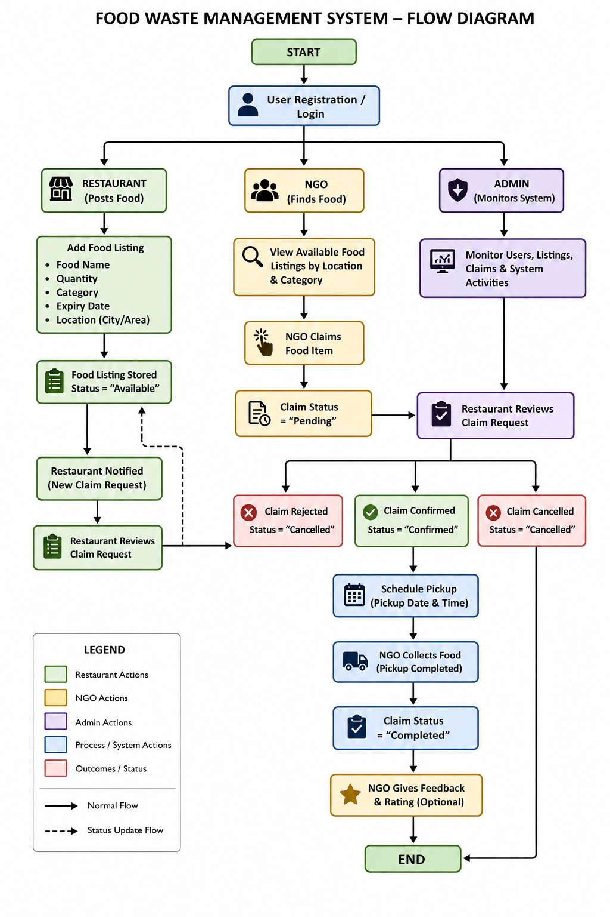
Food Waste Management System · Milestone 1 · Faraz Qazi & Maaz Ali · 4th Semester

